NDHD Coloured Polo Shirt Options 2020
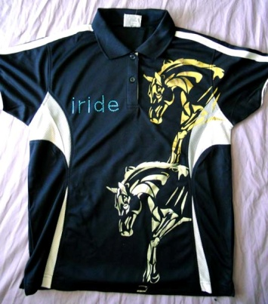
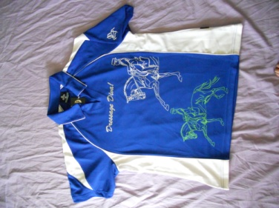
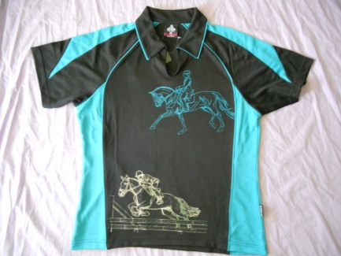
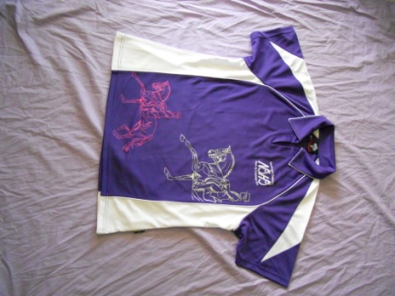
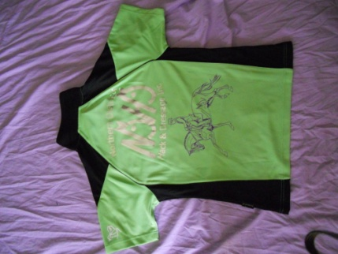
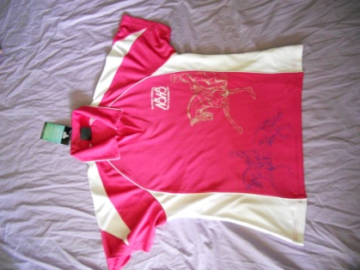
Black and White
Sizes: Ladies 8-24
Mens S-5XL
Royal and White
Sizes: Kids 6-16
Ladies 8-26
Mens S-5XL
Teal and Black
Sizes: Kids 6-16
Ladies 8-26
Mens S-5XL
Purple and White
Sizes: Kids 6-16
Ladies 8-26
Mens S-5XL
Apple and Black
Sizes: Kids 6-16
Ladies 8-26
Mens S-5XL
Pink and White
Sizes: Ladies 8-26

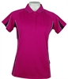
Please note these represent the colour options only. All polo’s will have NDHD logo and horse designs.
Cost is $35
Place order on form below
Made by HOT FILLY
www.hotfilly.com.au
Trina
mob 0438199780
NDHD inc. 2020 Polo Shirt Order Form

Cost per shirt $35

Colours | Available Sizes
 | Kids | Ladies | Men’s
Purple & White | 6 – 16 | 8 – 26 | XS – 3XL
Apple Green & Black | 6 – 16 | 8 – 26 | XS – 3XL
Royal Blue & White | 6 – 16 | 8 – 26 | XS – 3XL
Pink & White | N/A | 8 – 26 | N/A
Pink Black & white | 6-16 | 8 - 26 | N/A
Navy & White | N/A | 8 - 26 | S – 4XL
Teal & Black | 6 - 16 | 8 - 26 | XS – 3XL

- NOTE – Pink & White , Navy & White are NOT AVAILABLE in Children’s Sizes

Name | Colour | Size | Quantity | Price | Paid
 |  |  |  | $
 |  |  |  | $
 |  |  |  | $
 |  |  |  | $
 |  |  |  | $

Total Price | $

- Delivery time’s approx 2-4 weeks after order is received. Pick up is usually available before next competition or at the competition.

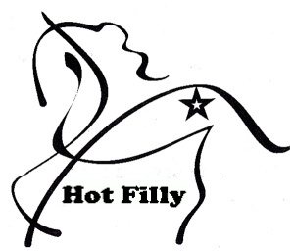
Shirts made by Hot Filly
Email order form to:
trinajohnq@iprimus.com.au
Payment via Direct Deposit
Heritage Bank
TL & JL Quarman BSB 638010
Acct 6196802 ref “Your Name”

